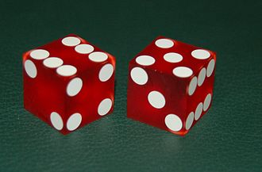
C/C++ ROLL DICE HISTOGRAM ASSIGNMENT AND LAB REPORT

1) Enter your name, student ID, platform (Mac or PC) and date
Name and Student ID: Jay Gupta, Student ID: 0961979
Platform (Mac, PC, Linux, etc.): PC
Development System (Visual Studio, Xcode, etc.): Visual Studio
Date: 3/19/2020
Sample Output
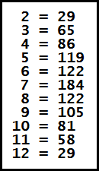
OBJECTIVES:
Enter and run a C or C++ program that uses a function.

DESCRIPTION:
Design a C or C++ program that does the following:
1) Use a loop to simulate the rolling of a pair of dice 1000 times. ✔
2) Use the function provided named roll to simulate the rolling of a single die. ✔
3) Write a function named rollDice to simulate the rolling of two dice by calling
the roll function twice. ✔
4) Count the number of times each value from 2 to 12 occurred. You will need a separate counter for each value. If the value is 2, then increment its counter. If the value is 3, then increment its counter, etc. ✔
5) Display the result of each of the counters. ✔

LAB REPORT:
2) Complete the HIPO table below – Since this table is not already filled out, you need to complete it yourself.
INPUTS | PROCESSING | OUTPUTS
- None | - For each of a thousand iterations:  - Get the value from rolling two dice.  - Update the ‘counter’ array accordingly.  - Update the numberOfRolls (add 1).  - Print out how many times each value was rolled by iterating through the loop. | - Number of times each value from 2 to 12 were rolled

DISCUSSION:
3) Complete the DISCUSSION section. It does not need to be long, but it needs to be complete.
3a) What did you do to develop the program? ("Followed the Directions" is not a complete description).

First, I decided on whether I was going to use if/else statements, case statements, or an array. Naturally, I wanted to use the array, because I had never in C++, and was looking for a challenge. I learned how an array works, and how to iterate through it to print values and get its size. Then, I learned how to implement a dice, and created the roll2Dice function. Finally, I put it all together and made the program, making sure that there were no bugs.

3b) The value of 7 should occur most often when two dice are rolled, and the values 2 and 12 should occur the least often. How does your program correspond to these expectations?

When it is run each time, the value ‘7’ occurs the most, and it descends on both sides equally, like a bell curve. In fact, the more times one rolls (I set it to 1,000,000,000 once), the more it shows the appropriate distribution, of a peak at 7, and the least at the ends, at 2 and 12.

3c) What problems did you have and how did you overcome the problems?

I had a few issues implementing the array; at first, it was giving me weird values for its contents, which I fixed by ‘initializing’ the array. I also had trouble iterating through the array, as I come from learning Java primarily, and it is much easier and intuitive as compared to C++. To fix these issues, I researched online, through help articles how one implements such an array, and through viewing my errors, debugging, and more internet searches, I was able to successfully implement the array.

PROGRAM OUTPUT:
4) Show four screen shots of the program running four different times.
Place only the section of the screen that shows the output of the program. Refer to the Paycheck lab report for instructions on capturing only a portion of the screen to place in the lab report.

1.
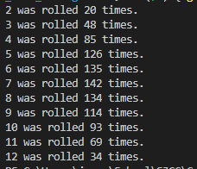

2.
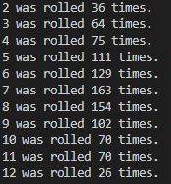

3.
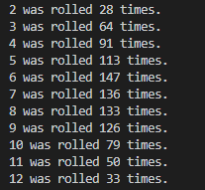

4.
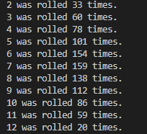

PROGRAM LISTING:
5) Copy and paste the code that YOU typed to make the program work. Your program should include a comment block at the top that shows the name of the program, date and your name.

/**
* Name: Jay Gupta
* StudentID: 0961979
* Date: 3/19/2020
* Program Name: C++DiceRollHistogram.cpp (V1.0)
* CIS054 C/C++ Programming
*
* Inputs: None
* Outputs: How many times each value from 2 to 12 were rolled
*/

#include <iostream> // for cin and cout
#include <ctime> // for time function
using namespace std;

int roll();
int roll2Dice();

int main() {
int numberOfRolls = 0;
int rolledValue = 0;

int counter[11] = {};

while (numberOfRolls < 1000) { // roll the dice 1000 times
rolledValue = roll2Dice();
counter[rolledValue - 2]++;
numberOfRolls++;
}

size_t n = sizeof(counter) / sizeof(counter[0]);

int firstValue = 2;
for (size_t i = 0; i < n; i++) {
cout << firstValue << " was rolled " << counter[i] << " times." << endl;
firstValue++;
}

return 0;
}

// returns a random integer from 1 to 6 (inclusive)
// (one dice)
int roll() {
// static variables - keep same memory location until program ends
static bool randomInitialized = false;

int points;

if (!randomInitialized) {
srand((unsigned int) time(NULL)); // initialize random
randomInitialized = true; // don't do it again
}

// rand returns value from 0 to largest possible integer
points = (rand() % 6) + 1; // points is from 1 to 6
return points;

return 0;
}

int roll2Dice() {
int die1 = roll();
int die2 = roll();

int total = die1 + die2;

return total;
}

